# Tutorial week 1

## Revision Test [work in pairs]

1. What is an entity?

a) An object b) an array c) a class

2. What is appropriate naming for an entity

a) In singular form b) in plural form

3. Which of the following is not an entity?

a) Student b) Priestley c) Computer d) student_phone_number

4. Which of the following is not an attribute?

a) venue_id b) car c) picture_name d) date

5. Which of the following are attributes of an entity called Customer?

a) customer_name b) address c) order_date d) delivery_date

6. Which of the following is an appropriate identifying attribute?

a) customer_name b) customer_email c) customer_id

7. Which of the following statements is correct?

1. An entity can have only one occurrence
2. An entity must have more than ONE occurrence

8. When identifying an entity type in the text you look for

1. Verb b) noun c) adjective

9. Which of the following below is not an occurrence?

a) Sanela Lazarevski b) Venue c) 22222 d) Booking

10. When drawing an ERD you should immediately identify cardinality of the relationships?

a) True b) False

11. When deciding the cardinality you base it on the information in the text.

a) True b) False

12. Relationships on an ERD normally don’t have a name.

a) True b) False

13. Choose cardinalities that can be defined on the relationship.

a) 1:M b) 1:1 c) M:N d) M:1

# Task 1:

Below are given entity names, attributes and occurrences. Your task is to complete the table below, and specify if given words are attributes, identifiers and/or an entity name. If it’s an occurrence, only highlight it with a circle on the list with a note of which attribute it’s an occurrence.

These attributes, entities, and occurrences described as a part of sales department database design record’s for full time and part time sales staff, who work on shifts. Each member of staff is expected to attend an induction course such as First Aid and many other relevant courses. All sales staff has to have a driving license, and each full time sales is assigned a car. Each department has a number of jobs allocated.

Work in pairs. You’ve got 15min for this task. When you finish exchange your work in class to mark each other’s work any. Good luck! I am sure you will enjoy this tutorial.

|  |  |  |  |  |  |  |  |  |
| --- | --- | --- | --- | --- | --- | --- | --- | --- |
| MOT_expiry | | date_of_birth | vehicle | make | reg_no | F654DWR |  |  |
|  |  | employee | | model |  | citroen |  |  |
| forename | |  |  |  | shift |  | shift_date |  |
| surname | | address_line1 | |  |  |  |  |  |
|  | dept | address_line2 | | hours | job |  | gender |  |
| First Aid |  | mobile | course | rota |  |  |  |  |
| job_id |  | ~~date_completed~~ |  | day |  | ethnic_group | |  |
| job_description | ~~course_name~~ | | ~~Course_id~~ |  |  | registered_disabled | | |
| Transport | Induction | Employee_id | | dept_name | dept_id |  |  |  |

1. List your Entities and Attributes in the table:

(Occurrences not specified in table, these should be used as reference for the relationships on the ERD in task b):

|  |  |  |  |  |  |  |  |  |
| --- | --- | --- | --- | --- | --- | --- | --- | --- |
| **Entity Name** | **Identifier** | **Attribute** | **Attribute** | **Attribute** | **Attribute** | **Attribute** | **Attribute** | **Attribute** |
| *COURSE* | *Course_id* | *Course_name* | *Date_completed* |  |  |  |  |  |
|  |  |  |  |  |  |  |  |  |
|  |  |  |  |  |  |  |  |  |
|  |  |  |  |  |  |  |  |  |
|  |  |  |  |  |  |  |  |  |
|  |  |  |  |  |  |  |  |  |

1. Draw your ERD below, and specify your assumptions and 4 validation questions for your ERD:

(Example of a validation question: *Which shifts did John Campbell work on in the past two months?* To be able to answer this question we will need entities employee and shift, which would hold attributes such as employee name, and shift_date)

Exchange work and review each other’s *(this is optional…used only if tutorial done in class)*

This work is:

Excellent Pretty Bad

Why is it good/bad?

How could it be improved?

This may help when you review the ERD(similar marking schema is used in your assignment for the ERD task)….

|  |  |  |  |  |  |
| --- | --- | --- | --- | --- | --- |
| Task 1 | 1st | 2.1 | 2.2 | 3rd | Fail |
|  | Excellent deployment of extended modelling skills, with complete and accurate coverage of advance entity models, cardinality, optionality, relationship naming in accordance with requirements, including appropriate support of sample queries. | Mostly accurate entities identified need to address requirements with correct cardinality. Some advance models included. Relationship names specified. | Partly addressed all issues on the model, with errors in relationships naming, cardinality and wrong appliance of one advance entities models. | Requires further work to address errors in relationships naming, cardinality and incorrect appliance of advance models. | Omissions or inaccuracies in model, showing lack of understanding of extended modelling approaches. |

Produce an ERM for each of the following situations. On the ERD diagram be sure to label and identify the cardinality and optionality of each relationship.

**Task 2a:** Medical Practice – Data Modelling (Conceptual Modelling)

In a group medical practice each doctor has many patients registered but a patient can only register with one doctor. Doctors may exist within the group that have no registered patients e.g. if they are involved only in research, but each patient must be registered with a doctor.

Step 1: Underline all nouns in the text above and list them below:

Step 2: Ask yourself, is your noun

* an attribute of an entity, or
* an occurrence of an attribute or
* An entity, which would have more than ONE occurrence and it is relevant to our system (case study)

Step 3: List below your entities and check your final list with your tutor

Step 4: For each entity create a table defining attributes and occurrences

Example: Entity Name

|  |  |  |  |  |  |  |  |  |
| --- | --- | --- | --- | --- | --- | --- | --- | --- |
| attributesName |  |  |  |  |  |  |  |  |
| Occurrences |  |  |  |  |  |  |  |  |
| Occurrences |  |  |  |  |  |  |  |  |

Step 5: Draw your ERD, by defining entities, relationships, relationship names cardinality. [How would your ERD change if past registrations are included?]

**Task 2b:** Medical Practice – Logical Design and Implementation

1. Derive Tables below following Relational Data Model (RDM) rules

Step 1: Identify Relations/tables and all attributes

Step 2: Identify Primary key(s) for each relation/table

Step 3: Derive Foreign Keys following the RDM rules

2. Log into Apex Account and create a script for the tables above. This is link to access your Oracle Apex account: <https://aet-oracle3.aet.leedsbeckett.ac.uk:8443/ords/f?p=4550:1:4237837431079:::::>

3. Create an Apex application, using Application Builder (AB) to add data into your tables. Go to Application Builder > Create > new application >specify name and click on create application botton. Next go to Create page > master detail > stacked> page name (Patient System) > next > create new navigation entry (home) > next, (Master Region Title – Doctor), (select table Doctor), primary key column (leave **rowid**)> Next > Detail Region Title –Patient, table – patient, Primary Key – **rowid**, master detail foreign key doctor_id – doctor_id > create > create > run.

Add some data, for an example see below:

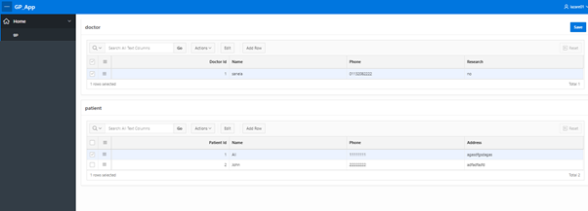

4. Check data in the OB after using the Application Builder (AB). Discuss in pairs, what are advantages and disadvantages using AB to add your data.

5. Now create a classic report, go to create page> report > classic report >title: details of patients>next>create a navigation menu entry (home)>next>SQL query (type in the code below) and click validate > create > run.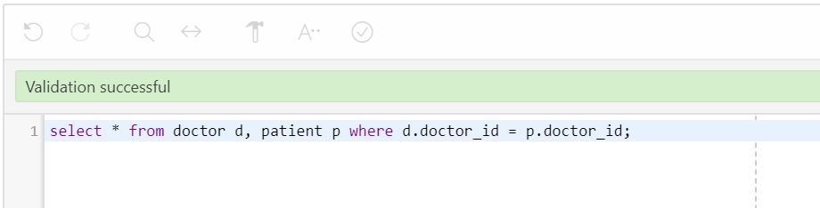

**Task 3:** Logical Design – Revision

Derive this model fully, by defining ***foreign keys*** for the relevant tables.

Below is the ERD’s description:

*Every project requires a number of employees. It is usual for consultants to work on more than one project at a time. Each project is broken down into individual tasks which are allocated to specific consultants. Some tasks are common to any project. Consultants meet regularly with clients by making appointments with them.*

Note: When you are completing the task to derive keys from your ERD, no retrospective changes should happen to the ERD design.

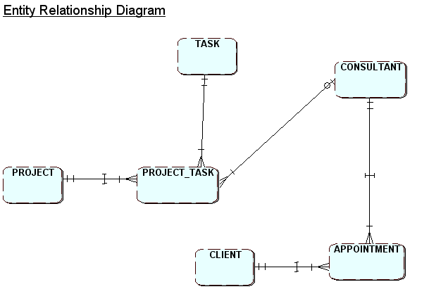

Derive Tables below following Relational Data Model (RDM) rules

Step 1: Identify Relations/tables and attributes

Step 2: Identify Primary key(s) for each relation/table

Step 3: Derive Foreign Keys following the RDM rules

Steps 1 and 2 have already been completed for you below.

Step 3:

Task(Task_id, Task_Name,…

Project( Project_id, Project_StartDate, Project_EndDate,…

Project_Task(PT_id, Desc,…

Consultant(Consultant_id, Name, Address, Phone,…

Client (Client_id, Name, Address, Phone,…

Appointment(Appointment_ref, Date, Location,…

* **In which normal form is this model?**